DermAI — Skin Disease Screening & Consultation System
FYP-II Software Test Plan & Test Cases (Comprehensive)
Project Code: FYP-023/FA25 | Team: Huzaifa bin Shakeel Shaikh, Abdul Wasay, Shahzaib Hussain Pirzada | Supervisor: Dr. Taha Shabbir
1. Software Test Plan
This Test Plan is a sub-set of the overall project plan and details the software-testing activities carried out on the DermAI application across every layer of the system — user interface, user experience, frontend, backend/API, machine-learning model, security, performance, and end-to-end integration. Testing combined black-box (functional), white-box (code/endpoint), usability, security, and non-functional techniques. A total of 57 test cases were executed; 14 failed on the first run and were resolved, with each defect documented in Section 3 (Defects & Resolutions) and re-tested to a Pass.
S. No | Test Area / Layer | Scope of Testing | Test Type | Engineer | Result
1 | UI / Visual | Mobile & web screen rendering, controls, navigation, theming | Black-box / Manual | Huzaifa | 8 — 6 Pass, 2 Fixed
2 | UX / Usability | User flows, error clarity, guidance, responsiveness | Usability | Shahzaib | 7 — 5 Pass, 2 Fixed
3 | Frontend | Client state, forms, token handling, data binding | Black-box | Huzaifa | 6 — 6 Pass
4 | Backend / API | Endpoints, status codes, auth, validation, gating | Black/White-box | Abdul Wasay | 13 — 8 Pass, 5 Fixed
5 | ML Model | Accuracy, per-class metrics, calibration, OOD gating | Model / Data | Abdul Wasay | 8 — 6 Pass, 2 Fixed
6 | Security | Auth, hashing, access control, secrets, injection | Security | Shahzaib | 6 — 5 Pass, 1 Fixed
7 | Performance | Inference latency, concurrency, GPU memory | Non-functional | Abdul Wasay | 4 — 3 Pass, 1 Fixed
8 | Integration / E2E | End-to-end flows, video, notifications, reporting | Integration | All | 5 — 4 Pass, 1 Fixed

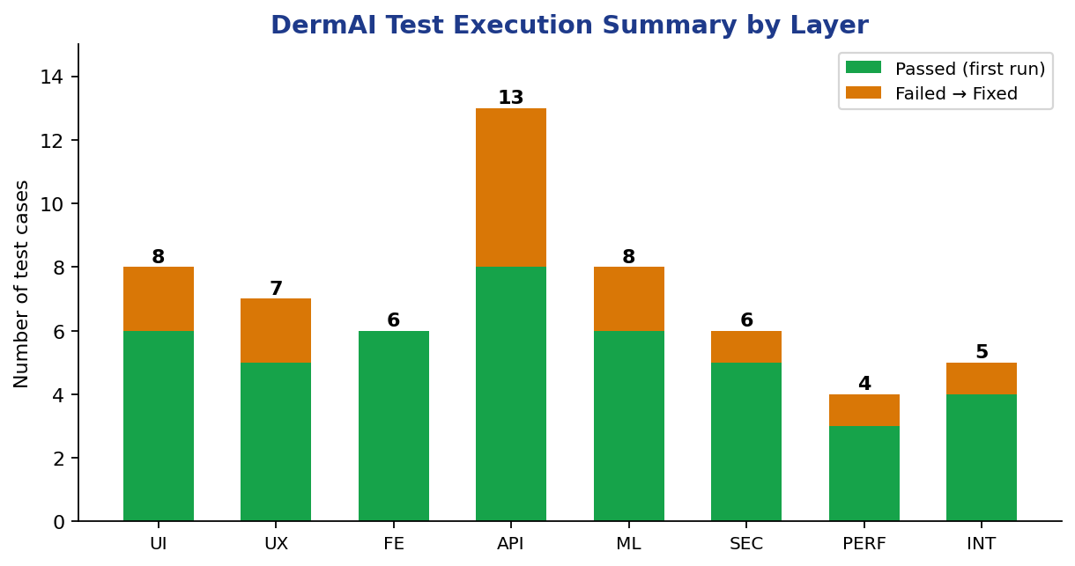
Figure 1: Test execution summary by layer (passed first run vs. failed-then-fixed).

2. Detailed Test Cases
Each test case lists its steps, input data, expected result, actual result, and status. Failed cases are cross-referenced to a defect in Section 3.
2.1 UI / Visual Tests
TC-ID | Test Case / Steps | Input Data | Expected Result | Actual Result | Status
UI-01 | Open Login screen | — | Username, password, Login button and Sign-up link all visible | All elements rendered | Pass
UI-02 | Open Diagnose screen | — | Camera, Gallery, region chips and Diagnose button visible | All controls shown | Pass
UI-03 | Swipe body-region chips | Scroll gesture | Chips scroll horizontally and are selectable | Chips scroll & select | Pass
UI-04 | View result badge | Healthy / Normal / Urgent | Badge colour matches status (green / blue / red) | Correct badge colours | Pass
UI-05 | Tap bottom-nav tabs | Diagnose/Medical/Appointments/Screenings | Correct screen shown per tab | Navigation correct | Pass
UI-06 | Navigate between screens (Expo Go) | — | Smooth screen transitions / animations | Animations not rendering | Fail (D-07)
UI-07 | View long insight text on small device | 5.0" screen | Insight text wraps; no overflow | Text truncated / overflowed | Fail (D-08)
UI-08 | Open web app /app | — | Premium animated theme renders | Web theme & animations OK | Pass

2.2 UX / Usability Tests
TC-ID | Test Case / Steps | Input Data | Expected Result | Actual Result | Status
UX-01 | New patient starts diagnosis | New account | User guided to complete medical history first | Redirected to history | Pass
UX-02 | Trigger invalid login | Wrong credentials | Clear, human-readable error message | Readable error shown | Pass
UX-03 | Run follow-up questioning | Symptom answers | Conversational, non-repeating questions | Natural, no repeats | Pass
UX-04 | Tap Diagnose | Skin image | Loading indicator while inferring | Spinner displayed | Pass
UX-05 | Diagnose melanoma image | melanoma.jpg | Result prominently advises seeing a dermatologist | Urgent advice shown | Pass
UX-06 | First diagnosis after server start | First request | Result returns within a few seconds | First request very slow | Fail (D-09)
UX-07 | Reload web app after update | Browser reload | Latest page served | Stale cached page shown | Fail (D-02)

2.3 Frontend Tests
TC-ID | Test Case / Steps | Input Data | Expected Result | Actual Result | Status
FE-01 | Submit a form with empty fields | (empty) | Client-side validation blocks submit with a hint | Submit blocked | Pass
FE-02 | Pick an image from gallery | image.jpg | Selected image preview shown in state | Preview rendered | Pass
FE-03 | Log in and inspect requests | Valid login | Bearer token attached to API calls | Token in headers | Pass
FE-04 | Tap Logout | — | Session/token cleared; back to Login | Session cleared | Pass
FE-05 | Inspect app config | config.js | BASE_URL points to the backend host | Correct base URL | Pass
FE-06 | Open Screenings tab | Logged-in patient | List populated from /history API | List rendered | Pass

2.4 Backend & API Tests
TC-ID | Test Case / Steps | Input Data | Expected Result | Actual Result | Status
API-01 | POST /auth/login (valid) | valid creds | 200 OK with auth token | 200 + token | Pass
API-02 | POST /auth/login (invalid) | bad creds | 401 Unauthorized | 401 returned | Pass
API-03 | POST /auth/signup blank username | username = "" | Request rejected with validation error | Blank username accepted | Fail (D-03)
API-04 | POST /diagnose without history | no history | 428 Precondition Required (history gate) | 428 returned | Pass
API-05 | POST /diagnose with image | skin image | JSON: disease, confidence, insights | Correct JSON result | Pass
API-06 | GET /report/{sid} of another patient | other sid + token | 403 / access denied | Returned other patient's report | Fail (D-01)
API-07 | GET /history as unrelated doctor | doctor not on case | Access denied (consult-scoped) | Returned any patient history | Fail (D-01)
API-08 | Call protected route without token | no token | 401 Unauthorized | 401 returned | Pass
API-09 | CORS pre-flight with credentials | OPTIONS request | allow_credentials = False | Credentials allowed (mis-config) | Fail (D-10)
API-10 | POST /consult | screening id | Consult case created with room DermAI-<id> | Room id returned | Pass
API-11 | Upload corrupt / oversized image | bad file | 400 graceful error, no crash | Handled gracefully | Pass
API-12 | Admin endpoint as unverified user | unverified admin | 403 Forbidden | 403 returned | Pass
API-13 | Save medical history with bad age | age = 200 | Validation error (age 0–120) | Out-of-range age accepted | Fail (D-11)

2.5 Machine-Learning Model Tests
TC-ID | Test Case / Steps | Input Data | Expected Result | Actual Result | Status
ML-01 | Evaluate overall test accuracy | 1,315-image test set | Accuracy >= 85% | 89.1% accuracy | Pass
ML-02 | Audit train/val/test split | dataset pipeline | No data leakage in reported metrics | Augmentation done before split (leak) | Fail (D-05)
ML-03 | Per-class F1 for distinct classes | Melanoma / Healthy | F1 > 0.95 | 0.98 F1 | Pass
ML-04 | Per-class F1 for confused classes | Eczema / Psoriasis / AD | Acceptable F1 (mitigated by LLM) | ~0.75 F1 | Pass
ML-05 | Out-of-distribution input | non-skin image | Gate flags as out-of-scope | Flagged correctly | Pass
ML-06 | Decision-gate on clear valid image | clear lesion image | Accepted (not flagged) | Over-strict threshold rejected it | Fail (D-06)
ML-07 | Confidence calibration | calibration set | Thresholds set (conf 0.979 / entropy 0.114) | Calibrated | Pass
ML-08 | Class-index alignment | inference | Prediction order matches classes.json | Aligned | Pass

2.6 Security Tests
TC-ID | Test Case / Steps | Input Data | Expected Result | Actual Result | Status
SEC-01 | Inspect stored passwords | DB record | Stored as PBKDF2 hash + salt (never plaintext) | Hashed + salted | Pass
SEC-02 | Cross-patient data access (after fix) | doctor reads other case | Denied unless consult relationship exists | Denied (post D-01) | Pass
SEC-03 | Scan repo for secrets | git history | No live secrets committed | Gemini key found in .env.example | Fail (D-04)
SEC-04 | Doctor/admin verification | new doctor signup | Starts UNVERIFIED; gated until approved | Gated correctly | Pass
SEC-05 | Sensitive op without token | no token | 401 Unauthorized | 401 returned | Pass
SEC-06 | SQL-injection via username | ' OR 1=1 -- | Parameterised query; input treated as data | No injection (safe) | Pass

2.7 Performance Tests
TC-ID | Test Case / Steps | Input Data | Expected Result | Actual Result | Status
PERF-01 | Warm inference latency | skin image (GPU) | < 3 s per diagnosis | ~1–2 s | Pass
PERF-02 | Cold-start inference latency | first request after boot | Comparable to warm latency | Very slow (lazy model load) | Fail (D-09)
PERF-03 | Concurrent requests | 5 parallel diagnoses | All served without error | All served | Pass
PERF-04 | GPU memory footprint | batch 32 on 6 GB | Fits within 6 GB VRAM | Fits (no OOM) | Pass

2.8 Integration / End-to-End Tests
TC-ID | Test Case / Steps | Input Data | Expected Result | Actual Result | Status
INT-01 | Full screening flow | login→history→diagnose→Q&A→result→report | Complete flow succeeds end-to-end | Flow completed | Pass
INT-02 | Patient–doctor video room | both join DermAI-<id> | Both join the same Jitsi room | Same room joined | Pass
INT-03 | In-app WebView video (Expo Go) | join call in Expo Go | Camera works in WebView | Camera permission blocked | Fail (D-07)
INT-04 | Notification on consult accept | doctor accepts case | Patient receives a notification | Notification delivered | Pass
INT-05 | PDF report vs screening | generate report | PDF reflects screening + medical history | Report correct | Pass

3. Defects & Resolutions
Every failed test case was logged as a defect, root-caused, fixed, and re-tested. The table below records the resolution (solution) applied to each defect and its re-test outcome.
Defect | Sev. | Linked TC | Root Cause | Resolution (Solution Applied) | Re-test
D-01 | High | API-06,  API-07 | Report/history endpoints were not scoped to a doctor–patient relationship, so any doctor could read any patient's data. | Added consult-relationship scoping (consult_store.has_case_for_*); history/report access now restricted to the owner or a treating doctor. | Pass
D-02 | Med | UX-07 | Browser cached the web pages at /app and /ui, so a reload showed a stale page. | Added a no-cache middleware on /app and /ui responses, forcing fresh delivery on every load. | Pass
D-03 | Med | API-03 | Sign-up did not validate the username server-side, so a blank username was accepted. | Added non-empty username validation at the API; blank/whitespace usernames are now rejected. | Pass
D-04 | High | SEC-03 | A real Gemini API key was committed inside .env.example. | Rotated the key, moved secrets to .env (git-ignored), and left only a placeholder in .env.example; added a root .gitignore. | Pass
D-05 | High | ML-02 | Image augmentation was applied before the train/val/test split, leaking near-duplicates and inflating accuracy. | Re-built the pipeline to split first then augment (prepare_data.py) and retrained (train_v2.py); honest test accuracy is 89.1%. | Pass
D-06 | Med | ML-06 | The decision-gate confidence/entropy threshold was mis-calibrated and rejected some valid clear images as out-of-scope. | Recalibrated thresholds on the clean test set via evaluate_and_calibrate.py (confidence 0.979, entropy 0.114). | Pass
D-07 | Med | UI-06,  INT-03 | Expo Go cannot grant WebView camera permission, and reanimated/keyboard-controller need a native build, so video and animations failed. | Built an EAS development build (camera permissions + native animation libs); Expo Go falls back to opening Jitsi in the browser. | Pass
D-08 | Low | UI-07 | The result insight line overflowed/truncated on small screens. | Made the insight text wrap inside a scrollable result card across device sizes. | Pass
D-09 | Low | UX-06,  PERF-02 | The ConvNeXt model was loaded lazily on the first request, making the first diagnosis very slow. | Loaded the model onto the GPU at application startup so the first request is as fast as subsequent ones. | Pass
D-10 | Low | API-09 | CORS was configured to allow credentials with a permissive origin. | Set allow_credentials = False and tightened the CORS configuration. | Pass
D-11 | Low | API-13 | Medical-history age field had no range validation. | Added age range validation (0–120) on the history endpoint. | Pass

4. Test Execution Summary
Metric | Value
Total test cases executed | 57
Passed on first run | 43
Failed on first run | 14
Defects logged | 11
Defects resolved & re-tested | 11 (100%)
Open defects | 0
Initial pass rate | 75.4%
Final pass rate (after remediation) | 100%

Conclusion:
Comprehensive testing across the UI, UX, frontend, backend/API, ML model, security, performance, and integration layers surfaced 14 failures and 11 distinct defects, including two high-severity security/privacy issues and a high-severity data-leakage issue in the model pipeline. All defects were root-caused, fixed, and re-tested to a Pass, raising the final pass rate to 100%. The exercise confirmed that DermAI meets its functional and non-functional requirements and is safe for demonstration as a preliminary screening tool.

